**Technological Adaptation and the Role of Social Media in the Proliferation of the Newly Created Minim Script from Burkina Faso**

Jannis Kostelnik

**Author**: **Jannis Kostelnik**, Centre for the Study of Manuscript Cultures, University of Hamburg, Hamburg, Germany. **Email**: jannis.kostelnik@uni.hamburg.de [1]

**Published date:** Dec 04, 2023

[Creative Commons License](https://creativecommons.org/licenses/by-nc-sa/4.0/) This article is licensed under a Creative Commons Attribution-Noncommercial-Share Alike 4.0 International License (CC BY-NC-SA 4.0).

**How to cite the article:** Jannis Kostelnik, “Technological Adaptation and the Role of Social Media in the Proliferation of the Newly Created Minim Script from Burkina Faso,” *Ahyu: A Journal of Language and Literature* 6 (2023): 71 – 87.

DOI: doi.org/

**Abstract**

This paper seeks to present an emerging, academically yet undocumented alphabetic script invented by Mahamadi Ouédraogo (*1983), an Islamic scholar from Burkina Faso. This script, called *minim biisi* (“Letters of Knowledge”) by its creator shows some historical continuities both to other West African Scripts as well as to Islamic traditions of cryptography and secret alphabets, yet at the same time offers interesting insights into the creative endeavours of a script creator in the digital age. Drawing on my fieldwork with the inventor of the script and some of his closest adherents in Ouagadougou, this contribution traces how Ouédraogo resolved the challenge of digitalizing his script by employing open-access font-creating software, thus avoiding regulating authorities such as the Unicode Consortium, Burkinabè policymakers, and software developers. It presents the various fonts he has created for his script and the possible issues and difficulties posed by some characteristics of his script, which are cross-linguistically rarely encountered. Additionally, it seeks to document how social media and social networks such as Facebook, YouTube, and WhatsApp play a role in the proliferation of this script and how these proliferation efforts are received by digital audiences. Due to the internationality of social media, these audiences are not only found within Burkina Faso, but also in the diaspora, which is reflective of the creative and decisive roles diasporas have played and continue to play in the creation and proliferation of West African Scripts, especially N’ko.

**Keywords:** *West African Scripts; Social Media; Script Development; Burkina Faso; Grassroots Literacy*

**Introduction: The Minim Script and its Script Creator**

For at least 190 years, 'Indigenous'[2], i.e. non-Latin-, non-Arabic-based scripts have emerged throughout West Africa (and less so in other regions of the African continent). While at least three dozen of these scripts have so far been documented and further, unreported, cases exist, these scripts have in the past attracted comparatively little attention both from paleographists as well as from African Linguists: the perception of Africa as a largely illiterate continent led to a focus on its ancient scripts (Egyptian, Meroitic, Libyco-Berber) by paleographists and to a focus on spoken language and oral literature by African linguists.[3] Nonetheless, these West African scripts show a great amount of variation with both syllabic and alphabetic scripts represented, and they consistently offer fascinating insights into processes of script creation and attempts at language revivalism coming from L1 speakers of the respective languages.

As mentioned above, literature is scarce on the topic; except for the Vai script used by the ethnolinguistic group of the same name in Liberia, (which is the oldest West African Script known so far), and the N’ko script, (which was developed in Côte d’Ivoire in the 1940s and is now fairly widely used around Manding-speaking areas of Mali, Guinea and western Burkina Faso).[4] More commonly found than monographs on single West African Scripts are comparative or introductory articles, among which especially Dalby’s (1967-70) tripartite article as well as the works of Tuchscherer (2007) and Kelly (2018b) go significantly deeper than listing the various West African Scripts and also try to investigate script creators' inspirations and motivations and establish cross-connections between scripts and creators. The most recent and comprehensive overview is from Rovenchak & Buk (2020)[5], which also goes beyond West Africa to introduce scripts from Central and East Africa like the Mandombe Script used in the Kimbanguism movement in the DR Congo or the Mwangwego Script of Malawi.

One of the most recently created West African Script not mentioned in this overview is the Minim Script (Mooré *minim* “knowledge”), called *minim biisi* (“Letters of Knowledge”) by its creator, Mahamadi Ouédraogo, who was born in Lamba, in the Hauts-Bassins Region of western Burkina Faso in 1982.[6] Ouédraogo’s L1 is Mooré, a Gur Language, which is the most widely spoken language of the country, yet is in a minority position in the Western regions, where the most commonly spoken language is Jula, a Manding Language. Ouédraogo’s native village is however predominantly Mooréphone. Born as the son of a Qur'ānic teacher, Ouédraogo was introduced to the Arabic script and Islamic religion at the age of ten and became a gifted student. He also describes having experimented with the Arabic Script for writing Mooré but was quickly dissatisfied when he realised that the script lacked the graphemes to represent all sounds of Mooré – Ouédraogo recounts being especially puzzled when his brother and elders told him that /p/ and /v/were impossible to write with the Arabic Script, as they did not exist in the language. In retrospect, he states that this event triggered his wish to derive a script for his native language, Mooré. Following the early death of his father, Ouédraogo was educated in the study of the Qur'ān, and also in Islamic Esotericism (*ʿilm al-bāṭin*) and traditional healing, by his elder brother, who took over the Qur'ānic school. Ouédraogo was later sent away to study with a Tijaniyya Sufi Sheikh in northern Burkina Faso.

After his education, he travelled widely around North and West Africa as an itinerant Qur'ān teacher and healer. In 2006, when he was staying in Faladjé, a neighbourhood of the Malian capital of Bamako, he experienced a dream vision: "diamond-like shapes" descending from the sky. When he awoke, the shapes of the letters of his script appeared in the air before him, and he subsequently copied them into a notebook. He spent the next years working on the script, yet states that whomever he showed it to was critical of it, leading him to almost abandon the project, until, in another vision, he was commanded to proliferate his script. Since then, Ouédraogo has engaged in small-scale proliferation of his script, self-publishing three documents in and about it and teaching it to a small group of initiates, using modern media. Next to that, he uses the script in his job, one which he describes as being a “practitioner of traditional medicine, especially for spiritual matters.”.[7]

Linguistically, the Minim Script constitutes an alphabetic script with elements of an Abjad (i.e. a consonantal script in which vowels are expressed through diacritics, cf. Arabic or Hebrew) as it consists of 21 consonantal graphemes (cf. Fig. 1) corresponding to the consonantal phonemes of Mooré and three basic vowel graphemes named A, Yi and Wou (two of which – Yi and Wou – also double as consonants /w/ and /y/). With these, the 13 vowel phonemes[8] of Mooré are expressed by combining a basic vowel grapheme with one of 6 vowel diacritics. The basic vowel A[9] can be combined with a vowel diacritic to represent the vowels /a/ and /ã/, and the basic vowel Yi can be combined with a vowel diacritic to represent the vowels /e/, /ẽ/, /ɛ/, /i/, /ĩ/ and /ɪ/. The basic vowel Wou can be combined with a vowel diacritic to represent the vowels /o/, /õ/, /u/, /ũ/ and /ʊ/ as well as the diphthong [o͜a] (cf. Fig. 2). Vowel lengthening is expressed either with a diacritic or with a special grapheme signifying lengthening, which follows the lengthened vowel. Additionally, several diacritics exist with which features like reduplication, free variation of some consonants, and phonemes absent from Mooré (e.g. in Arabic terms) can be marked. One of these diacritics – called *Taʿrīb* (“Arabisation”) in Ouédraogo’s works on his script – is crucial, as it shifts the phonetic value of some consonant graphemes from a phoneme only existing in Mooré to a phoneme only existing in Arabic, thus enabling the user to write both Arabic as well as Mooré with the same set of graphemes (cf. below).

Another remarkable aspect of the Minim Script and one in which the script creator takes great pride, is its bi-directionality, i.e. the fact that it is possible to write from both right-to-left (sinistrograde) as well as left-to-right (dextrograde), for which two variants of the script have been created, which differ only very slightly to cater for angles which might be difficult to negotiate in handwriting. Following Ouédraogo, this was done to accommodate new script initiates who might be familiar with Latin or the Arabic Alphabet.

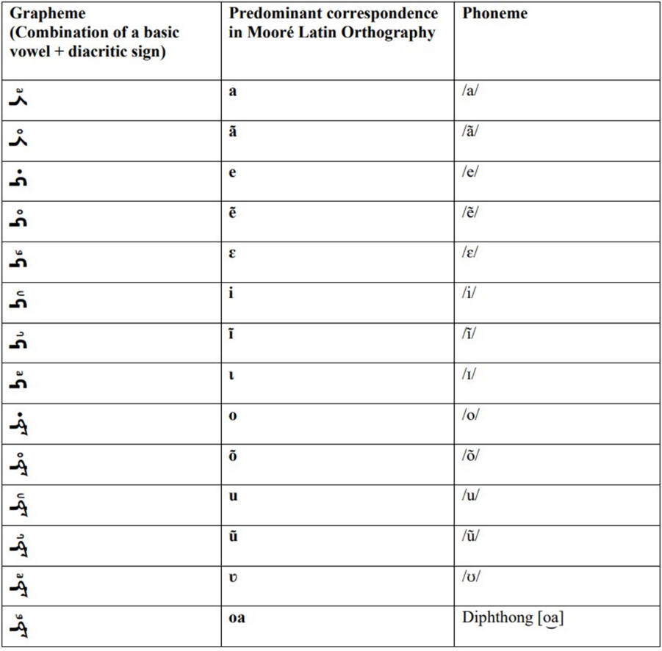

***Figure 1: Consonant graphemes of the Minim Script***

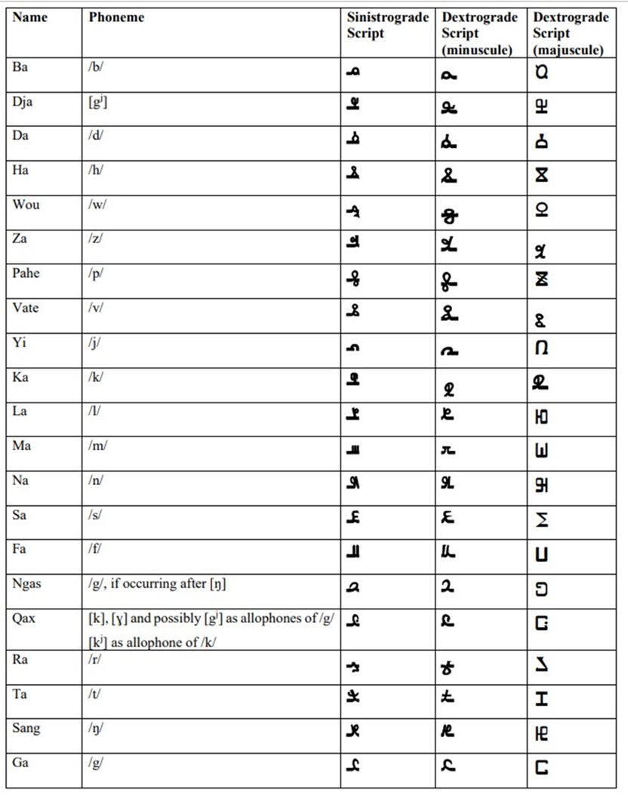

*Figure 2: Vowel graphemes of the Minim Script*

*Both figures were created for Kostelnik (2023: pp. 50 & 61).*

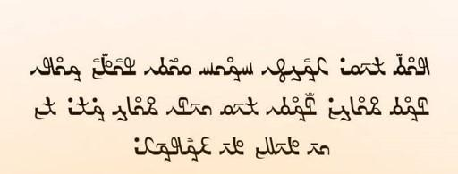

*Example of a short digital text consisting of greetings and blessings which was produced by Ouédraogo on the occasion of ʿĪd al-Fiṭr in May 2023.*

**Methods**

The results presented in this paper were obtained during six weeks of fieldwork in Ouagadougou, the capital of Burkina Faso, in August and September 2022. This fieldwork was undertaken in the framework of my Master’s Thesis “Mahamadi Ouédraogo’s Mooré Script[10] in the Context of West African Script Creation”, submitted in early January 2023.

During this period, I was jointly hosted by the Joseph Ki-Zerbo University of Ouagadougou and the Institute for Social Sciences of the National Centre for Scientific and Technical Research (CNRST-INSS), also in Ouagadougou. Most of my work was at the INSS, including two prolonged interview sessions with Mahamadi Ouédraogo, during which his assistant Karim Tapsoba served as an interpreter. Another meeting with Ouédraogo, scheduled to take place between the two interview sessions needed to be cancelled, as I fell ill and required several days of bed rest. During the first of our interview sessions, we discussed general questions on the functioning of his alphabetic script, about his CV and his life before the development of the script as well as about his knowledge of scripts and languages other than his mother tongue Mooré and the Arabic Script and language, which he learned during Qur'ānic education. Additionally, he gave a detailed account of the vision in which he claimed to have received his alphabet before he gave me the three documents in which he had explained the alphabet.

During our second meeting, I reiterated some of my questions on the functioning of the alphabet and more on Ouédraogo’s CV and personal life, which had remained unclear in our first meeting. Also, we discussed questions of orthography in his script and its technical implementation as well as his ways of sharing it through social media. In the meantime, I carried out interviews with local experts – i.e. scholars working at Université Joseph Ki-Zerbo or the INSS in Ouagadougou – about their encounters with the script creator as well as on topics of orthography development, language policy, and the role of the Arabic Script in Burkina Faso. Additionally, I studied the script with the help of the three documents that Ouédraogo handed to me to be able to read and – at least rudimentarily – write it myself and thus be able to ask more concise and scientifically relevant questions during the second meeting.

**Technical Implementation of the Script**

Developing technical solutions such as computer and smartphone keyboards for West African Scripts is a decisive matter for the survival of any such script and may represent a serious obstacle in this task, due to the presence of regulatory authorities such as the Unicode Consortium[11] and the high costs (relative to the script creators' incomes) of professional freelance software developers. Ouédraogo encountered such a problem during the process of creating the Minim Script: During one interview he recalled that, after he first sought publicity for his script and inquired about a software developer, he was delegated to a company in Ouagadougou’s neighborhood of technology and economy, Ouaga 2000, which initially suggested a fee of 3 000 000 Franc CFA (4573€) for their work, far beyond Ouédraogo’s financial means. They subsequently reduced the fees, offering to develop software for 600 000 F CFA (914€), still a large sum, especially since a plea to the Ministry of Secondary Education was declined, because – as Ouédraogo’s assistant stated – the ministry did not consider the script to be useful. While this sum could eventually be gathered, the project failed for unknown reasons, with Ouédraogo stating that the finished product was “not functional”. Thus, he decided to take the matter into his own hands, and with the help of a (partly) open-access font creation software, he inserted the shapes of his letters into an Arabic Script template. Ouédraogo did not state exactly which program he employed, but according to the metadata of one of the fonts, the program in question was FontCreator 11, developed by the Dutch software company High-Logic. Since this font creation software makes use of pre-existing fonts – one of the fonts is, according to the metadata, based on Calibri Arabic – it permits the export of the graphemes into a format recognised by common word processing software (i.e. Microsoft Word), Ouédraogo thus managed to create several fonts with which to write the script on standard PCs without any need for special (and expensive) software, theoretically enabling learners and literates to produce Minim documents.

The following figures show the Minim Keyboard (Fig. 3) in comparison with an Arabic keyboard (Fig. 4) and, finally, the phonetical correspondences of the keys of the Minim Keyboard:

77

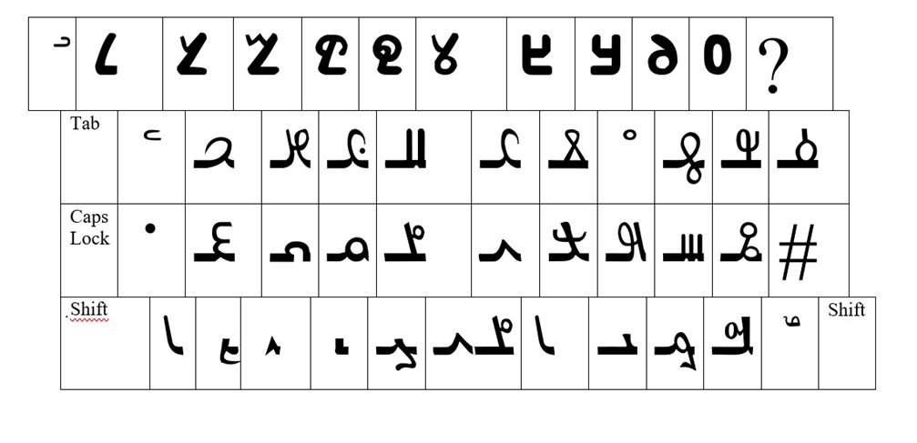

*Figure 3: The Minim Keyboard*

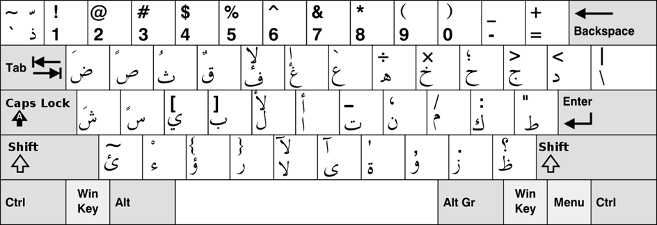

*Figure 4: An Arabic Keyboard*

*Available online at:* [*https://upload.wikimedia.org/wikipedia/commons/a/af/KB_Arabic.svg*](https://upload.wikimedia.org/wikipedia/commons/a/af/KB_Arabic.svg)*.*

78

78

*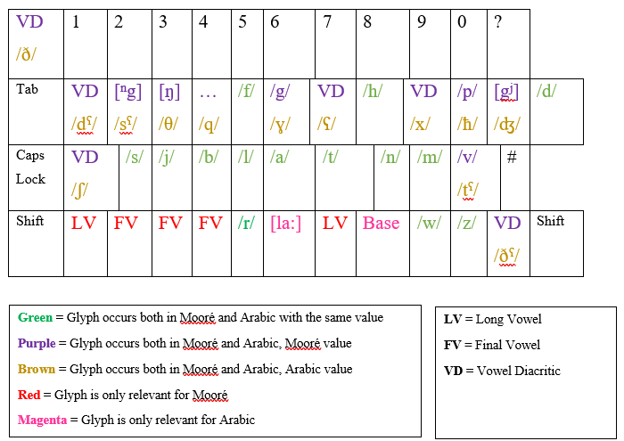Figure 5: Correspondences*

Through the above figures, it becomes clear that the Minim computer fonts are based on Arabic fonts, as the positions of Minim characters and Arabic characters with the same phonetic value overlap completely. [12]This becomes especially visible in those characters of the Minim Script which have the same phonetic value regardless of whether Arabic or Mooré is written in this script (unmarked in the above fig.). The characters that exhibit different phonetical values depending on the language of choice are marked in Bold and Italic, respectively. Those also overlap with the keys of the graphemes of corresponding phonetic value on an Arabic keyboard. The Mooré correspondences of those ‘doubly-encoded’ graphemes cannot all be represented with IPA symbols in the above figures, as some correspond to vowel diacritics[13] (VD), which only receive meaningful phonetic value when combined with one of the three basic vowel graphemes. Finally, the grapheme called Qax by Ouédraogo – corresponding to Arabic Qāf (/q/) – corresponds to several Mooré allophones of /k/ and /g/. Special cases are posed by those graphemes underlined as well as those in underlined italics in the above figure. The usage of the underlined graphemes is limited to writing Mooré with the Minim Script. Marked with LV is a special grapheme used for a long vowel, which resembles an Arabic Alif and, in writing Mooré with the Minim script, may succeed any basic vowel to express vowel length. This grapheme is not needed when writing Arabic in the Minim Script, as any occurrence of the three basic vowel graphemes by default corresponds to a long vowel. Additionally, marked with FV are three special shapes of the basic vowel graphemes occurring in the writing of Mooré in the Minim Script to express a word-final vowel. While the existence of these three graphemes is certainly inspired by the fact that Arabic letters may exhibit different shapes depending on their position in the word or connectedness to other letters, these three final vowels do not occur in Arabic written in the Minim Script; if a long vowel occurs word-finally, it is represented by the standard basic vowel grapheme.

The two graphemes marked by underlined Italics in the above figure are only relevant for writing Arabic in the Minim Script. One of these is a grapheme termed "Base", which is a default shape with no phonetical correspondence of its own, however, it needs to be present for these graphemes which represent Arabic consonant phonemes but Mooré vowel diacritics (cf. especially the upper row of the Minim Keyboard). It thus occurs in writing to show that no vowel but a consonant is present in this case (and, based on that, its presence is a clear indication that the language of a given text is indeed Arabic). The position of this grapheme on the keyboard is curious, as it is found on the position of the grapheme Tā' Marbūṭa on an Arabic keyboard. Tā' Marbūṭa is an indispensable grapheme of the Arabic Alphabet, marking (mostly) feminine lexemes ending in/a/. Ouédraogo has created a grapheme corresponding to Tā' Marbūṭa and employs this in writing Arabic in the Minim Script, yet this needs to be manually selected from the list of symbols.

Finally, the key corresponding to the Arabic Lām-Alif ligature presents a sort of ‘fringe case’, as pressing the key produces merely a Minim La (/l/), followed by the basic vowel grapheme A[14] and not a ligature as in Arabic. While this key needed to be filled in by the font-creating software, given that the Minim fonts are based on pre-existing fonts, it is not at all impractical also for writing Mooré to have a ‘shortcut’ to this letter sequence, as the lexeme *la* and the suffix -*la* has at least nine meanings in the language, several of which are highly frequent, including the emphatic form of the copula, conjunction linking nouns and pronouns[15], and the conjunction “but”.

I had the chance to try out the two fonts created by Ouédraogo – one called simply *Moore* and one called *Minim Dag Noore*, translated by Ouédraogo as “Gate of [Mooré] Knowledge”. This name is also sometimes used as a designation of the script itself. *Minim Dag Noore*, which is seemingly based on Calibri Arabic, provides graphemes of both the sinistrograde and dextrograde variants of the script depending on whether the PC language is set to Arabic or a Latin-based language, while *Moore* provides dextrograde graphemes only; if one sets the language to Arabic and selects this script, Arabic letters appear. The graphemes in this font are also always unconnected. While both scripts work sufficiently well, some issues are encountered in practical usage. These include the presence of both combining and non-combining diacritics (cf. Fig. 6), which can make the selection of some less commonly used diacritics cumbersome; several seemingly impossible combinations of graphemes and diacritics selectable in the "symbols" section (cf. Fig. 7) and the small size of Minim graphemes if the user utilises a typical 10 or 12pt font size. Additionally, a personal issue encountered was the difficulty of producing spaces between lexemes when using *Minim Dag Noore* in the sinistrograde version, which also startled Ouédraogo and was not the case on his PC.

80

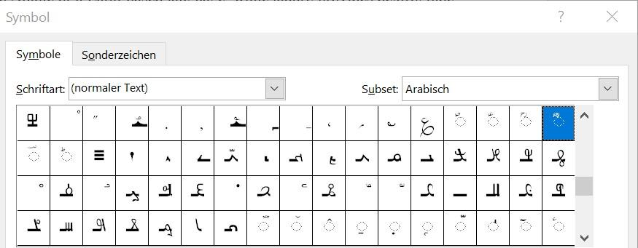

*Figure 6: The "Symbols" Section of the font 'Moore', showing both combining and non-combining diacritics*

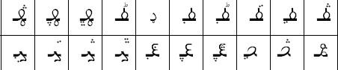

*Figure 7: Several seemingly 'impossible' combinations of graphemes and (Arabic) diacritics*

A pending issue for Ouédraogo is certainly the adaption of his script for smartphone keyboards, given the ubiquity of these communication devices in West Africa and their cheaper price compared to PCs. He stated, that while it would be greatly beneficial for the proliferation of his script, he did not find a solution for this matter as of yet. While technically, font creation programs also exist for mobile devices, the implementation of these created fonts in instant messaging services may prove more difficult than that of newly created fonts in word processing software, given that they would need to be capable of being functional in a large number of Apps and within several different mobile phone operating systems.

In general, the importance of technical adaptation of the Minim Script has been strongly emphasised by Ouédraogo during our interview and he is very clearly aware of the necessity of such fonts in the digital age. This preference has led to a bias towards printed and digital texts in my Minim corpus – the only handwritten texts I possess are a photocopy of Ouédraogo’s first notebook and a few leaves with single words and sentences which Ouédraogo produced upon elicitation during our interviews, to clarify some of my questions.

**Social Media and the Proliferation of the Minim Script**

Social media has been used by script activists for the proliferation of several West African Scripts, with N’ko being at the forefront of these efforts: A YouTube search for ‘Apprendre le N’ko’ or merely ‘N’ko’ renders dozens of videos uploaded by several creators aiming at people wishing to learn the script. Other scripts for which several learning videos have been uploaded include Adlam and Mandombe. The Minim Script has also been made accessible on YouTube, mainly owing to the work of Ouédraogo’s assistant Karim Tapsoba, who is also responsible for the creation of the video showing a translation of the Burkinabé National Anthem transliterated into the Minim Script. This has been the most successful Minim-related video on YouTube[16], where the script creator and his assistant are present with two channels, the main channel *Moore. com*, and another channel, called *mahamadi Ouédraogo*. Neither of the channels however has been updated for several years. On *moore. com*, 16 videos were uploaded, including a re-post of a broadcast of the Burkinabé national television presenting Ouédraogo’s project. Other videos include pronunciations of the letters and a partial recording of Ouédraogo’s first visit to the Institute of Social Sciences (INSS) in Ouagadougou. Two videos show classroom situations, in which Ouédraogo is teaching the script to a group of people and two further videos are dedicated to the National Anthem of Burkina Faso in Mooré, one video presenting it in the Latin Alphabet and one presenting it in Minim Script. Five more videos concerning the script were uploaded to the channel *mahamadi Ouédraogo*, among them what might be the oldest record of the Minim Script on social media, a video entitled *Alphabet en moore miniim dag nooré inventé au burkina faso[17]* uploaded on 17th March 2017. In this video, Ouédraogo films the graphemes and diacritics as well as some words, which are written on a wooden board pinned to a wall, and reads them out loud. The remaining three videos concern the pronunciation of the graphemes, while the final video is concerned with Mooré proverbs and is entitled *Moor yelbuna Moor bipaala[18]* (roughly “Mooré proverbs [in] new Mooré [letters]"). This video shows a reading of several Mooré proverbs in combination with music. Additionally, a man is depicted whom I could not identify but who may be a collector of proverbs.

81

Apart from the National Anthem video, none of the YouTube videos has reached a wide audience – this one has around 26,800 views as of early 2023. On average, the videos on *moore. com* has around 100 views, with some more and some less than that. The videos on the other channel, *mahamadi Ouedraogo*, all received less than 100 views; they have not been commented upon extensively. The video of the National Anthem on the other hand has received more comments which are generally patriotic, as is commonly found under videos of National Anthems.*La patrie ou la mort nous vaincrons* (“Fatherland or Death, we will win”), or utter statements like *merci beaucoup une fierté d’être Burkinabe* (“Thank you very much, [I feel] proud to be Burkinabé”). Only one comment may be interpreted to relate to the script, it says: *Merci bcp pour cette traduction. Je suis en train de l’apprendre*. (…) (Thank you very much for this translation. I am currently learning it"). However, it remains unclear whether this relates only to the Mooré translation or also to the lyrics of the National Anthem in the Minim Script.

Users engage far more widely with the script on another social media platform, Facebook. There, the only video material consists of re-posts of the broadcast of the Burkinabé national television outlet RTB on Ouédraogo and his script, posted by community pages of Mossi and Burkinabé interest, with names such as *Faso 226*[19] or *Zone Mossi*. Most of the comments praise the idea of the script, with some taking decidedly political stances such as *… c’est la base de l’indépendance On ne peut pas être indépendant en parlant la langue du colonisateur*. (“… this is the base of independence. One cannot be independent speaking the coloniser’s language.”). It is remarkable that, despite these often decidedly anti-French statements, the words are predominantly formulated in French. The only exception is the comments under a repost of an association called *Zone Mossi*, which are predominantly written in Mooré.[20] These are also overwhelmingly positive and read e.g. *yaa sonma y barka* (“It is a blessing, thank you”) or *barka zone mossi wend paassi barka la laffi la sougri la poupelim bark wendé* (“Thank you, Zone Mossi, [for sharing], may God give blessing and health and forgiveness and honesty, God bless.”).

82

In general, if criticism towards the script is raised, it is mostly not in defence of the use of Latin for the Mooré language, but the fact that the alphabet bears visual similarities to the Arabic script. It is also significant that the most pronounced comment of criticism comes from a non-Burkinabé woman who, according to her Social Media presence, works for a Christian NGO, stating that "arabizing” Mooré is not a good thing” and that “Mooré, as it is taught now (…) is completely appropriate, because foreigners can easily learn it since they are familiar with the letters."

Finally, the social media platform most commonly used by Ouédraogo at the moment is WhatsApp, where he and his assistant have gathered (also by inviting users who have positively commented on Facebook) several dozen Mooré L1 speakers in two WhatsApp groups, called *Nouvel Alphabet Mooré* and *Pratique la langue mooré*, respectively. At irregular intervals, Ouédraogo posts pre-recorded videos to both these groups. These videos are similar to the style of teaching encountered in the teaching videos on YouTube, drawing on the Qur'ānic schooling techniques of repetition of letter names, shapes, and corresponding sounds. Interestingly, not all users seem to be based in Burkina Faso as shown by the international dialling codes of their phone numbers: Next to the Burkinabé dialling code +226, several +225 numbers (Côte d’Ivoire) can be found in the group – not too surprising given the close relations of both countries and a large number of Burkinabé living in the country. Other West African dialling codes are uncommon, only +222 (Mauritania) and the neighbouring countries +223 (Mali) and +229 (Benin) are represented. European or more broadly "Western" dialling codes are scarce, with only +1 (USA) and +39 (Italy) represented.[21] The largest diaspora in the WhatsApp group is made up of members based in the Middle East and Arabic countries, especially in Libya (+218), Jordan (+962), Kuwait (+965), and – quite surprisingly – Iran (+98).

While these countries – except for Libya – do not feature in the overview of Burkinabé migration movements presented in Devillard et al. (2015: 98ff.), Atong et al. (2018: 11ff. + 41) mention migration from West Africa to the Gulf countries, albeit on a rather small scale. While data and studies on these migration movements are scarce and almost non-existent in the case of Burkina Faso, it can be suspected – also considering some of Ouédraogo’s statements during the interview – that this diaspora is intrinsically linked to religion and made up of Burkinabé seeking higher Islamic education in these countries, thus being more interested in the Minim Script, which is strongly connected to Islam. Nonetheless, the high number of group members based in Iran remains puzzling, due to its small economic importance compared to the remainder of the GCC countries and especially its different Islamic confession as compared to West Africa, given that most Iranians adhere to Shīʿa Islam. West Africans are overwhelmingly Sunnī Muslims.

While Ouédraogo’s efforts are far less professionalized and of a far smaller extent, this aspect of proliferation in the diaspora is also encountered in scripts such as Adlam and N’ko. According to the website of the Adlam activists’ group *Winden Jangen*, they have in the past undertaken at least one large journey to West African Fulfulde-speaking communities outside Guinea, [22]For the proliferation of N’ko, videoconferences were already widely used in the mid-2010s to connect N’ko activists and learners in West Africa, as it was in the USA and Arabic countries, as exemplified by the sessions described by Donaldson (2017: 37f.). It is at this point of the Minim script's development very hard to tell how many people are fully fluent in reading and writing, next to Ouédraogo and his assistant Karim Tapsoba. In the RTB video and several videos posted on the creator's YouTube channel, one can see the early stages of alphabetisation classes with didactic practices similar to those encountered in Qur'ānic education. However, from these videos alone, it is unclear how many followed these courses and how thoroughly they learned the alphabet. The crowd in the creator’s videos seems to consist of roughly a dozen boys from early teenage to adolescent age, with a few older men seemingly in the back of the classroom. In the RTB video, it is smaller, around 4-8 learners. During my stay in Burkina Faso, there did not seem to be any classes taking place, however, Ouédraogo did not give a clear reason for that and I did not inquire further than asking whether or not I could attend a class during my fieldwork. Since this was not possible, I cannot give additional information on these classes other than those mentioned above. Ouédraogo however stated that he was in the process of developing videos to teach his script via WhatsApp. As mentioned above, Ouédraogo has now begun posting these videos at irregular intervals. Sometimes, the Minim elements in these videos are handwritten, while most commonly, they are created with Ouédraogo’s Minim fonts. There is no direct writing of Minim script in the group.

83

Additionally, Ouédraogo stated that he also taught the script to some people in his former hometown of Bobo-Dioulasso and that he would also sometimes note things for his clients in Minim Script, however, it remains unclear how many clients can actually read the script and what extent it may also be regarded by them as a charm or talisman. Future research on the script should clarify to what extent the script initiates other than Ouédraogo uses the Minim Script, possibly also among themselves and especially in handwriting, given the current lack of handwritten documents.

**Conclusion**

In the preceding chapters, it has been shown how the script creator Mahamadi Ouédraogo has managed with comparatively little financial expense to bypass regulating authorities and high costs for software developers in creating a font for his script. While it remains unclear whether he created the fonts completely on his own, they constitute – just like the entire script creation project – an expression of Ouédraogo’s linguistic creativity and persistence. While there are some flaws in both fonts, they work sufficiently well for Ouédraogo and his adherents to produce written documents in the Minim Script, whether printed or digital only, with which they can reach an audience both in Burkina Faso and the diaspora.[23] A view on the Social Media responses towards his script has shown that, while far from unanimous, there is a tendency towards positive reactions to Ouédraogo’s script.

However, it needs to be stated that, although there are positive reactions to his script, it has not gained a large audience. All in all, the number of those who are fully literate in the Minim Script can be estimated to be a few dozen at most – not counting those who have expressed their interest in learning the script and are members of Ouédraogo’s WhatsApp groups – but probably less than that, with the majority being constituted by Ouédraogo’s acquaintances. The Minim Script is at this point comparable to another script with a creator originating from a similar educational background: the alphabetic script created by the Sudanese-Cameroonian Fulfulde scholar Modibbo Bello Aamadu Mohamadou[24] which was learned by a few interested people, but never systematically proliferated in the way that Ouédraogo uses Social Media for the proliferation of his script. It remains open whether the Minim Script will be learned extensively by people other than the creator's 'inner circle' and also taught by people other than Ouédraogo to reach the rank of a small movement, comparable to the Malawian Mwangwego Script[25], which had several hundred script literates as of 2010. Another possible trajectory could be the status of a script limited to what Unseth (2011: 30) calls the “small circle of ethnic revivalists” found repeatedly in the early stages of script developments – i.e. in the case of Minim, the creator, his assistants and some of their close adherents.

84

Nonetheless, from a scientific perspective it needs to be argued that also the emerging and even the unsuccessful among these scripts can give vital insights into the linguistic understandings of L1 speakers, how they conceptualise optimal orthographies for their languages, and the aspects of spirituality, religion, and politics they associate with script choice and orthography. This study of the technical adaptation of emerging West African Scripts like the Minim Script adds to these research strands the aspect of how the long-standing tradition of script creation in West Africa is transferred into the digital age of the 21st century.

**References**

Atong, K., Mayah, E. & Odigie, A. (2018). *Africa Labour Migration to the GCC States: The Case of Ghana, Kenya, Nigeria and Uganda*. ITUC-Africa. <https://www.ituc-africa.org/IMG/pdf/ituc-africa_study-africa_labour_migration_to_the_gcc_states.pdf>.

Battestini, S. (2007). African Writing, Text and the Arts: Concepts and Definitions. In: Mullen Kreamer, C. et al. (Eds.): *Inscribing Meaning. Writing and Graphic Systems in African Art* (pp. 28-36). Smithsonian Institution.

Cissé, M. (2006). Écrits et écriture en Afrique de l’Ouest. In: *Sudlangues*, 6, 63-88.

Cooper, R. L. (1991). Dreams of Scripts. Writing Systems as gifts of God. In: Cooper, R. L. & Spolsky, B. (Eds.): *The Influence of Language on Culture and Thought. Essays in Honor of Joshua A. Fishman’s Sixty-Fifth Birthday* (pp. 219-226). Mouton De Gruyter.

Dalby, D. (1967). A Survey of the Indigenous Scripts of Liberia and Sierra Leone: Vai, Mende, Loma, Kpelle and Bassa. *African Language Studies*, VIII, 1-51.

Dalby, D. (1968). The Indigenous Scripts of West Africa and Surinam: Their Inspiration and Design. *African Language Studies*, IX, 156-197.

Dalby, D. (1969). Further Indigenous Scripts of West Africa: Manding, Wolof and Fula Alphabets and Yoruba ‘Holy’ Writing. *African Language Studies*, X, 161-181.

Devillard, A., Bacchi, A. & Noack, M. (2015). *A Survey on Migration Policies in Africa*. ICMPD & IOM. <https://publications.iom.int/books/survey-migration-policies-west-africa>.

Dobrovolny, M. (2010, November 26). The Politics of Malawi’s Alphabet. *Speak Magazine*. <https://web.archive.org/web/20160304000609/http://speakjhr.com/2010/11/the-politics-of-malawis-alphabet/>.

Donaldson, C. (2017). *Clear Language: Script, Register and the N’ko Movement of Manding-Speaking West Africa*. [Doctoral dissertation, University of Pennsylvania]. Scholarly Commons, UPenn. <https://repository.upenn.edu/entities/publication/955cd518-cd8a-484a-98d6-bf5f08929c41>.

Donaldson, C. (2019). Linguistic and Civic Refinement in the N’ko Movement of Manding-Speaking West Africa. *Signs and Society*, 7:2, 156-185. https://doi.org/10.1086/702554.

Ferro, A. & Mutti, V. (2019). *Indagine sulla diaspora burkinabé in Italia: l’associazionismo e le sue relazioni transnazionali*. CeSPI. <https://www.cespi.it/sites/default/files/documenti/report_cespi_ass_bbe_italiafin_0.pdf>

85

Halirou, M. (2017). Moddibbo Bello Aamadu Mohammadu and the Daada Maaje, a Handbook in an Indigenous Fulfulde Script. In: Brigaglia, A. & Mauro Nobili, M. (Eds.): *The Arts and Crafts of Literacy. Islamic Manuscript Cultures in Sub-Saharan Africa* (pp. 299-308).

Kelly, P. (2018a). The Art of not being legible. Invented Writing Systems as Technologies of Resistance in mainland Southeast Asia. *Terrain*, 70. <https://journals.openedition.org/terrain/17103>.

Kelly, P. (2018b). The Invention, Transmission, and Evolution of Writing. Insights from the New Scripts of West Africa. In: Ferrara, S. & Valério, M. (Eds.): *Paths into Script Formation in the Ancient Mediterranean* (pp. 189-209). Edizioni Quasar.

Kelly, P. (2022). *The last Language on Earth. Linguistic Utopianism in the Philippines*. Oxford University Press.

Kelly, P., Winters, J., Milton, H. & Morin, O. (2021). The Predictable Evolution of Letter-Shapes. An Emergent Script of West Africa recapitulates Historical Change in Writing Systems. *Current Anthropology*, 62:6, 669-691. https://doi.org/10.1086/717779.

Kostelnik, J. (2023). *Mahamadi Ouédraogo’s Mooré Script in the Context of West African Script Creation*. [Unpublished master’s thesis]. Universität Bayreuth.

Niggli, U. (Ed.). (2016). *Mooré-French-English Dictionary*. SIL International. <https://www.webonary.org/moore/>.

Rovenchak, A. (2012). Numerical Notation in Africa. *Afrikanistik Ägyptologie online*. <https://www.afrikanistik-aegyptologie-online.de//archiv/2012/3553>.

Rovenchak, A. (2015). Quantitative studies in the corpus of N’ko Periodicals. In: Tuzzi, A., Benešova, M. & Macutek, J. (Eds.): *Recent Contributions to Quantitative Linguistics* (pp. 125-138). De Gruyter Mouton.

Rovenchak, A., Macutek, J. & Riley, C. (2009). Distribution of complexities in the Vai script. *Glottometrics*, 18, 1-12.

Rovenchak, A. & Buk, S. (2020). Indigenous African scripts. In: Vossen, R. & Dimmendaal, G. J. (Eds.): *The Oxford Handbook of African Languages* (pp. 797-812). Oxford University Press.

Tuchscherer, K. (2007). Recording, Communicating and Making Visible: A History of Writing and Systems of Graphic Symbolism in Africa. In: Mullen Kreamer, C. et al. (Eds): *Inscribing Meaning. Writing and Graphic Systems in African Art* (pp. 37-54). Smithsonian Institution.

Tuchscherer, K. & Hair, P. E. H. (2002). Cherokee & West Africa. Examining the Origins of the Vai Script. *History in Africa*, 29, 427-486. https://doi.org/10.2307/3172173.

Vydrin, V. (2010). Le Ńkó kɔ́dɔyidalan de Souleymane Kantè et la tradition lexicographique « occidentale » pour le mandingue. *Mandenkan*, 46, 73–98.

Vydrin, V. (2012). Une bibliographie préliminaire des publications maninka en écriture N’ko. *Mandenkan*, 48, 59–120.

Unseth, P. (2011). Invention of Scripts in West Africa for Ethnic Revitalization. In: Fishman, J. & García, O. (Eds.): *Handbook of Language and Ethnic Identity. Volume 2. The success-failure continuum in Language and Ethnic Identity Efforts* (pp. 23-32). Oxford University Press.

**Author’s profile**:

**Jannis Kostelnik** is a PhD Student and Research Associate at the University of Hamburg's *Centre for the Study of Manuscript Cultures* (CSMC) where he is pursuing the project "Prayer, Protection and Plant Medicine: West African Composite Manuscripts from the Wellcome Library". The project focuses on a corpus of magico-religious manuscripts in Arabic Script, especially on the role of African languages and ethnobotanical and ethnopharmacological knowledge in these texts. In 2023, he obtained an MA in African Verbal & Visual Arts from the University of Bayreuth with a thesis on the Minim Script, a hitherto undescribed West African script from Burkina Faso. He also holds a degree in Near and Middle Eastern Studies from Philipps University of Marburg, Germany. **Email**: jannis.kostelnik@uni.hamburg.de.

87

1. This paper is based on an MA Thesis in the study program "African Verbal and Visual Arts (AVVA)" at the University of Bayreuth. The author is a Research Associate at the Cluster of Excellence "Understanding Written Artefacts", based at the Centre for the Study of Manuscript Cultures of the University of Hamburg.

   Field research in Burkina Faso leading to the creation of the thesis was funded jointly by the University of Bayreuth and the German Academic Exchange Service (DAAD) within the framework of their "Promos" Scholarship.
2. While the term “indigenous West African Scripts” (or similar) is often found in studies on the topic (e.g. Dalby 1967-70; Unseth 2011), the term is rarely to never used for emergent scripts in different regions of the world (Kelly 2018a; Kelly 2022), which is why it is mostly avoided in my work on the Minim Script.
3. Cf. e.g. Battestini (2007: 28) and Cissé (2006: 68ff.).
4. Cf. e.g. Kelly et al. (2020) and Tuchscherer & Hair (2002) on Vai as well as Donaldson (2017, 2019) and Vydrin (2010, 2012), to name but a selection of the latter two authors, on N’ko.
5. Rovenchak et al. (2009) and Rovenchak (2015) have also provided quantitative-linguistic analyses of aspects of Vai and N’ko and a comprehensive overview of systems of numeral notation in West African Scripts is found in (Rovenchak 2012).
6. Ouédraogo’s biography is based on accounts he gave me during our interviews and on a document entitled "CV", which he sent to the National Research Centre of Burkina Faso in 2015, a digital copy of which is in my possession.
7. Translated from Ouédraogo’s CV, ca. 2016, cited in Kostelnik (2023).
8. While linguistic works on Mooré mention 13 vowels, one of which, /ɛ/, is a result of a collapsed diphthong, Ouédraogo’s alphabet makes use of 14 meaningful combinations of basic vowels and diacritics, as he considers the very frequent diphthong [o͡a] a vowel phoneme of its own.
9. The names of the letters mentioned in the following are those given to each letter by Ouédraogo (cf. Fig. 1).
10. As I had not been in contact with Ouédraogo before arriving in Burkina Faso, I was unaware of the name "Minim" used for the script, which is why it does not feature in the title.
11. For any script to be encoded into the Unicode standard, a proposal containing – as per Unicode’s proposal guidelines (<https://www.unicode.org/pending/proposals.html>.) – “references to dictionaries and descriptive texts establishing authoritative information” as well as “names and addresses of appropriate contacts within national body or user organizations” need to be submitted. These may be hard, in some cases even impossible to come by for small-scale script creators. Additionally, the language barrier may play a role, as Unicode’s website and proposal guidelines are, as of 2023, English-only.
12. Additionally, Ouédraogo created a set of numerals based on the Eastern Arabic numerals, which are visible in the top row of Fig. 3.
13. The fact that graphemes can represent vowel phonemes in Mooré but consonant phonemes in Arabic is necessitated by the much higher number of short vowel phonemes in Mooré (13, compared to the three of Arabic) and vice-versa, the higher number of consonant phonemes in Arabic as compared to Mooré.
14. Sometimes also termed “Alif” by Ouédraogo.
15. Most commonly translated as “and” (Niggli 2016: 541f.).
16. Available online at <https://www.youtube.com/watch?v=WLzXKKpK53A&t=15s>.
17. Available online at: <https://www.youtube.com/watch?v=Y0bPZK1gnTc>.
18. Available online at: <https://www.youtube.com/watch?v=QaMCnwyfdsU&t=9s>.
19. . 226 is a reference to the international dialling code of Burkina Faso, +226
20. Post available online at: <https://www.facebook.com/zonemooogho/videos/le-moor%C3%A9-sinternationaliseplusieurs-efforts-sont-faits-dans-ce-sens-zoom_sur_mah/1929295950448366/>)
21. The presence of Italian phone numbers is unsurprising given that “considering migration from […] Burkina Faso, one can state that Italy represents the preferred and most significant destination among European countries.” (Ferro & Mutti 2019: 8, own translation).
22. Available online at: <https://www.windenjangen.org/gallery>.
23. The most recent of these examples in my possession is a text consisting of greetings and blessings which was produced by Ouédraogo on the occasion on ʿĪd al-Fiṭr in May 2023 (cf. above).
24. Cf. Halirou (2017).
25. Described in Dobrovolny (2010).