**A Pragmatic Study of Social Media Communication among Students at the Federal University of Wukari, Nigeria**

Victor Elendu Frederick and Vivian Ijeoma Ogbazi

**Authors: (Corresponding)** **Victor Elendu Frederick,** Department of English and Literary Studies, Federal University, Wukari, Taraba State, Northeast Nigeria.

**Email**: victorfedrick03@gmail.com.

**Vivian Ijeoma Ogbazi,** Department of English and Literary Studies, Federal University, Wukari, Taraba State, Northeast Nigeria.

**Email**: cyprainvivian6@gmail.com.

**Published date:** Dec 04, 2023

[Creative Commons License](https://creativecommons.org/licenses/by-nc-sa/4.0/)This article is licensed under a Creative Commons Attribution-Noncommercial-Share Alike 4.0 International License (CC BY-NC-SA 4.0).

**How to cite the article:** Victor Elendu Frederick & Vivian Ijeoma Ogbazi,“A Pragmatic Study of Social Media Communication among Students at the Federal University of Wukari, Nigeria,” *Ahyu: A Journal of Language and Literature* 6 (2024): 88 – 101 .

DOI: doi.org/10.56666/ahyu.v6i.168

**Abstract**

The new media, also known as social media, among other things, promotes communication among students as well as language development in linguistically diverse contexts in Nigeria. On the university campus, students who have been experiencing difficulties in contributing to interactions in classrooms and other formal settings in the university, appear to find a voice in these electronically mediated spaces. Communication in digital spaces accommodates linguistic and paralinguistic cues. Thus, it is characterized by innovations, which include an admixture of languages and varieties of Nigerian English, graphics, memes, and emojis, among others. This study examines selected posts and comments on the Federal University Wukari Students’ Facebook page. Information from the analysis of data reflects the linguistic practices of the students, the kind of information and knowledge they share as well as their communicative procedure. Findings from the study also reflect on the sociolinguistics and implications of social media communications on the University community and society in general.

**Keywords:** *Pragmatics and context, social media communication, relevance theory, Facebook and students*

**Introduction**

Social media communication enables the true essence of language, linking people of diverse backgrounds, without necessarily considering deviations from dominant expectations of language as an error. It accommodates linguistic and nonlinguistic skills and other rhetorical strategies employed by interlocutors (Agustin & Ayu, 2021). Meltwater (2023) describes Facebook as the biggest social network worldwide with over 2.9 billion active users as of April 2023. These figures indicate that roughly 37.0% of the world's population uses this platform. This is why Facebook was chosen as a suitable social media platform for this study.

Being at the forefront of social media expansion, Facebook allows users to build a social network with millions of people around the globe, and university students are one of the primary demographics using Facebook, as a study by Eger (2015) shows. Its features such as photos, emoticons, wall posts, the ‘‘like button’’ concept (which defines the popularity of a page or post), status updates, better application programming interface, and chats make it a preferable option for social media users, especially students.

Worthy of note is that communication is achieved on Facebook through diverse languages and different varieties of the English Language, standard and nonstandard forms. It has been observed that students invent new forms and varieties of the English Language to suit their communicative needs in different contexts, without necessarily paying attention to the grammaticality of their utterances, yet the intended meaning is not compromised. This shows that understanding the social context and identifying intent is essential for effective communication on Facebook. It also proves that utterances can be understood or analyzed by interlocutors without necessarily relying on linguistic principles or assertions (Colston, 2018).

In this study, we aim to examine students' use of Facebook as a means of communication; identify some of the subject matters discussed by students in Facebook posts, investigate the strategies employed by students in Facebook communication, and determine the contextual meanings of students' posts on Facebook. The model of analysis serves to evaluate students' posts in the network of interest in an explanatory linguistic fashion to boost a better understanding of utterances or user-intended meaning during Facebook communication among students through context mediation and other pragmatic tools. Apart from filling the gap in the literature on the contextual meaning of Facebook posts by students and highlighting how students draw inferences from many shared assumptions, this study enriches in a wholesome manner, a database on communicative competence, relationships, vibrant academic experience, and social performance of students on campus.

The fast-paced digital age, characterized by the availability and rapid dissemination of large chunks of information, is gradually eroding the practice of keen attention to details while communicating through writing, a common practice of the preceding epoch – the print era. It has been observed that users of Facebook often shorten what they post owing to an awareness of the impatient disposition of most potential readers who barely spare time to read through lengthy posts, chats, or status updates to grasp its main idea. This explains why users most times use emojis, gifs, shortened writings, and abbreviations; non-standard forms of language, thereby, yielding new forms of writing during communication on this new media (Barton & Potts, 2013).

**Theoretical Framework**

Once an utterance is made, the human mind engages in a cost/benefit procedure intended to select, among the range of possible interpretations of the same stimulus in a specific context, the one (possibly) intended by the communicator. Relevance is a property of stimuli resulting from a positive balance between, on the one hand, the eventual interest that the stimulus might provide and, on the other hand, the mental effort required to process the stimuli. Relevance theory views utterance comprehension as an inferential process that is relevance-oriented (Sperber &Wilson 2002).

According to Sperber & Wilson (1995), understanding an utterance is a matter of inferring the speaker's communicative and informative intentions built on relevance. The greater the cognitive effect achieved, the smaller the mental effort required, and the more relevant an input becomes to an individual. This means that relevance to a purpose, question, or topic is a special case of relevance in a context or to an individual. Therefore, an input only achieves relevance geared towards maximum cognitive efficiency. The human cognitive system has developed a variety of mental mechanisms or biases that allocate attention to processing inputs with the highest relevance. An utterance is only relevant if it is worth the addressee's processing effort and compatible with the speaker's ability or preferences.

The input is the production of the speaker’s utterance as well as the contextual information which delivers as the output an interpretation of the speaker’s meaning. Utterance comprehension is a mindreading process, providing pieces of evidence combined with contextual clues to supply the intended meaning. A context comprises mentally represented information of any type, beliefs, doubts, worldviews, intentions, expectations, and likes, usually selected from contextual options available to the individual during the comprehension process.

In this framework, interpreting an utterance is carried out in parallel rather than in sequence. It is not a matter of first identifying the explicit content, then highlighting contextual assumptions, and deriving contextual implications, but of mutually adjusting explicit contents, contexts, and their implication and with the presumption of relevance until the first overall interpretation that makes utterance relevant in expected ways is achieved (Wilson & Sperber, 2002).

This study draws from the tenets of relevance theory (implicature, explicature, and contextual analysis as well as cognitive inferencing) to examine communication practices among students at Federal University Wukari, Nigeria.

**Methodology**

This study adopts a pragmatic approach -, Relevance Theory - in analyzing 4 statutes and 20 comments on various subject matters drawn from a popular student Facebook page, the Federal University Wukari Students' Forum, and finding clues for context identification. The sample comprises random posts from both male and female students of the Federal University Wukari campus between 17 and 30 years as the biodata on their profile pages. This is because members of this group are commonly considered the most active users of Facebook.

This research is qualitative as it addresses how and why students communicate on Facebook paying attention to context. The data are randomly selected posts and comments of students on a Facebook page, the Federal University Wukari Students' Forum, both male and female students of the Federal University Wukari campus between 17 to 30 years as the biodata on their profile pages show.

**Data Presentation and Analysis**

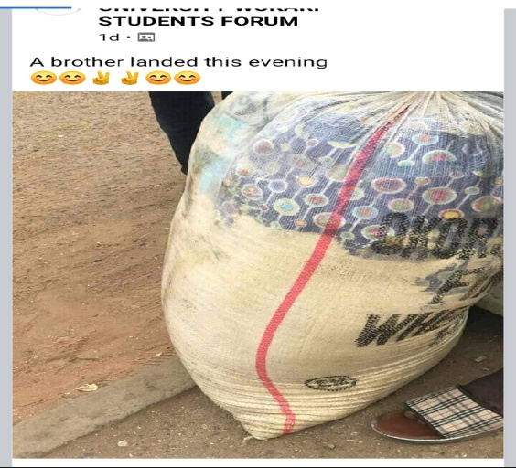

**Figure 1**

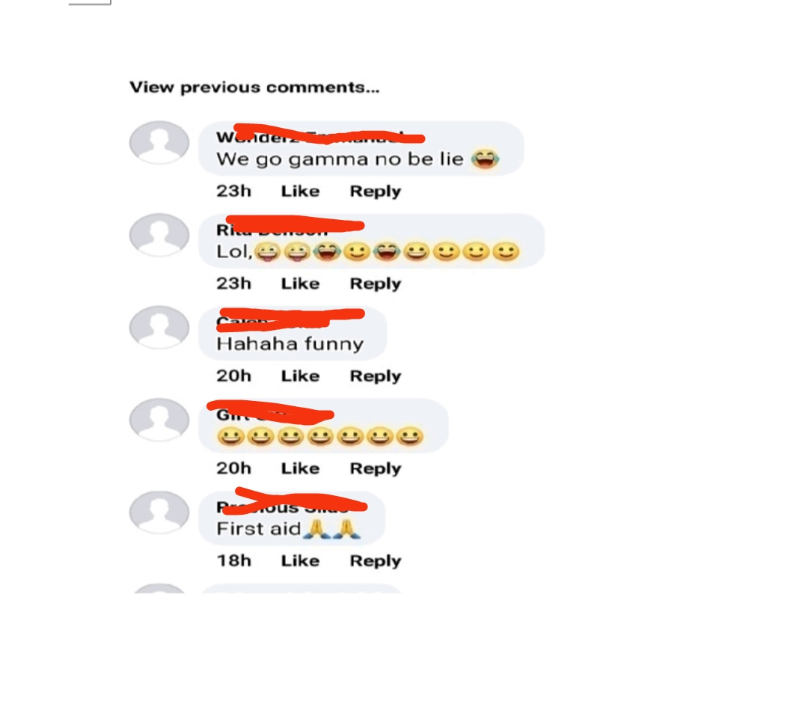

**Figure 2**

In the first post, the speaker uses graphics to support his/her comment, "A brother landed this evening". This kind of post can be considered an ambiguous perspective, as several meanings can be interpreted based on the audience. The speaker implicitly expresses surprise over the large number of food items that a fellow student has arrived with on campus. Within a university environment, this utterance appears to be worth the processing effort of the addressee. To deduce the implied and full meaning of the speaker's utterance, such as knowing that the place implied is the Federal University Wukari campus and that 'the brother' is not used literally, but refers to a fellow student, the audience relies on the shared background and contextual knowledge. In a creative sense, the speaker points out that a fellow student of Federal University Wukari is back on campus with essential food items inside a bag.

One of the eminent formal features of digital discourse is the picture attached to the utterances to support and aid interpretation. The speaker uses the image of a bag that he believes is filled with assorted food items for what communicative effect? In terms of relevance, the image is a communicative gesture, as it expresses in pictorial form the speaker's intended meaning and avails the audience of a better interpretation. The photo of a bagload of food items and two distinct accompanying emojis (a stunned face and two fingers raised as signs of victory over hunger) portrays the comic effect the addresser intends to elicit. Using pictorial images portrays a male personality and a written utterance that reflects how the speaker wants to be clownishly perceived online. It makes the audience view the speaker as a comical person who tries to depict how students humorously arrive on campus.

Perhaps, the speaker posted the above utterance at a 'special time' towards the end of a semester, like the examination period when food is usually scarce, and implicitly personifies the food items in the bag as 'brother'. The possible communicative intention of the speaker is evident in the fact that the supporting picture of his utterance- "a brother has landed", does not capture any male personality carrying the bag of food items depicted in the image. It is safe to infer that the speaker intends to personify the bag containing food items and ascribe a human quality "brother" to it.

The speaker relies on the shared knowledge of his audience that most students exhaust their foodstuff before the semester examination and become unusually clingy to food as they cling to their siblings. This contextually means that foodstuff is a worthy companion or sibling of students during hunger and a brother. This tends to maximize the relevance of this utterance through acts of ostensive communication.

Also, the emoji of two raised fingers creatively means victory over hunger due to the arrival of a "brother', which the speaker intends to communicate to his audience. If not for the shared academic and sociocultural background knowledge of members of the group that this speaker belongs to and the contextual clues provided, the interpretation of this utterance would have been elusive.

A post like this, comprising a picture with few words and some emojis, shows how using linguistic tools can draw many implications and inferences within students' communication on Facebook. This is one of the prominent features of digital discourse; many interpretations can be extracted from a few pieces of information. Thus, posts, like the above, require pragmatic tools to unravel the many inferences and implications that can be elicited through these types of posts.

The first comment, ‘We go gamma no be lie", is a typical example of the nonstandard use of the English Language (mixture of pidgin and Hausa) in students' communication on Facebook. It takes shared background and contextual knowledge that transcends the grammaticality of an utterance to comprehend that the speaker is expressing his ability alongside others to consume the food items depicted in the post. For instance, although the lexical item, 'gamma', is not an English but a Hausa word that means 'to exhaust or completely consume', it is contextually used in the utterance because the speaker assumes that the geographical (Northern Nigeria) and cultural background which he/she shares with the audience will aid communication of intended meaning. Here, the comment processes the utterance in the most relevance-enhancing way and responds accordingly in a mutual cognitive environment.

Also, the emoji (a face showing tears of joy) as well as the comment shows the commentator is joyous over the sizeable quantity of food items, especially gari, which is an essential food item to students, portrayed in the post captures the exact nuances of the communicative meaning of the post. The act of emotionally shedding tears of joy (through an emoji) implicitly communicates that the remedy for dire hunger has finally arrived for the commentator.

The second comment, 'lol', is a non-conventional way of saying that the commentator is laughing out loud, which can be classified as his/her most relevant inference. Using three different emojis (a grinning face with a tongue, a face showing tears of joy, and a grinning face with smiling eyes) shows the alternating communicative and pragmatic effect the post creates on the recipient. Thus, this commentator interprets the post as a comic one supported by the first emoji (a grinning face with tongue) without necessarily using the emojis (of a face showing tears of joy and a grinning with smiling eyes) as an expression of joyful emotion, but as an excessive outburst of humor.

The third comment, “hahaha funny” can be interpreted as “I am laughing broadly because the post is funny. The meaning of this comment is deduced through the contextual conditioning of the utterance elicited by the recipient. Hence, the meaning is implicitly linked to the addressee's interpretation of the post and the shared background knowledge such utterance evokes in the recipient. The speaker expresses excitement, devoid of any other possible creative meaning, as the pragmatic effect of the post. This inference gives insight into how the addressee interacts with the utterance.

The penultimate comment typifies how emojis can be solely used for communicative purposes on Facebook. The seven identical emojis (grinning face with smiling eyes) used by the commentator are an implied way of showing the pragmatic and communicative effect of excessive laughter evoked by the post. The commentator interpreted the post as a joke and responded appropriately. Thus, the emojis can be seen as a contextual assumption which sheds light on the speaker’s state of mind and emotional feeling of joy.

The last comment, “first aid’, shows how students react to posts and interpret the speaker's intended meaning differently. Here, the speaker considers the act of naming to be of optimal relevance. The phrase, “first aid”, carries a communicative hidden message and implies that the speaker names the bag filled with food items, first aid; the first or basic cure for hunger on campus. The emoji (of clasp hands) expresses the commentator’s gratitude or satisfaction over the availability of food items (first aid).

The responses also show how students use Facebook posts to achieve various communicative ends, which include sharing jokes.

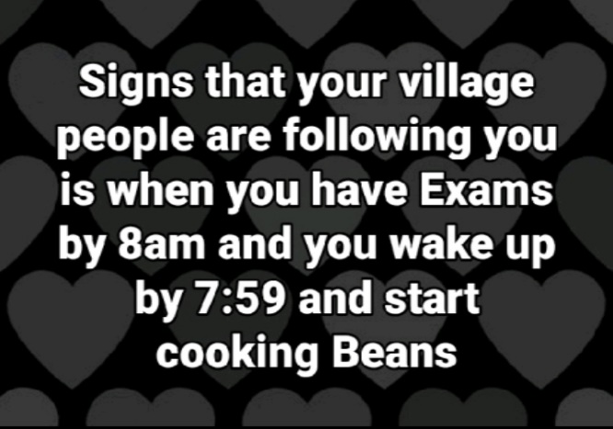

**Figure 3**

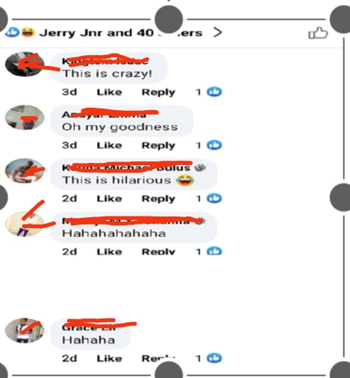

**Figure 4**

This post captures a hypothetical examination situation in the words of the speaker. Here, the speaker communicates one of the possible signs that a student is under a spell or spiritual attack when a student who has an examination at 8 am wakes up at 7: 59am and decides to cook beans. The post can be seen as an attempt to enlarge the mutual cognitive environment of interlocutors; hence, the speaker states a possible sign that a student is being monitored by negative invisible communal forces (described as village people).

Consequently, the writer's utterance implies that a sane student will not begin to cook beans a minute before the examination time. Perhaps, "beans" in this utterance stands for any food that takes a lot of time to cook. The post updater uses it in this utterance to communicatively infer that a student who cooks any time-consuming food a minute before the examination time will ultimately miss the examination.

The meaning of this utterance is deduced through the similar African cultural and contextual background of the speaker and his audience; otherwise, the communicative import of the utterance may prove difficult. For instance, it is through the shared cultural perspective that the audience can decipher the nonliteral meaning of "village people" (not as individuals who live in rural settings) as negative malevolent superstitious forces that are believed to limit, in this context, the academic progress of some students. The speaker and members of his speech group share a set of contextual properties, belief in superstition.

In this utterance, the speaker implicitly advises his addressees on managing their priorities with proper time management, such as waking up early and not distracting oneself with chores like cooking. Thus, the speaker implicitly advises his audience to avoid waking up late during the examination period and cooking a few minutes before examination time, but to prepare well before every examination to avoid apportioning blame to superstitious malevolent forces. The pragmatic effect of this utterance reflects a call for adequate preparation for every examination.

The first comment, “This is crazy", highlights the cognitive effect of assessing and asserting. The commentator having assessed the post confirms that it is indeed crazy for a student to wake up one minute before the stipulated examination time to cook or do anything other than rush to the examination venue. Thus, the utterance, "this is crazy", implies that it is not a superstitious phenomenon, but sheer foolishness for a student who should have been in the examination hall to decide to cook beans. This utterance portrays the pragmatic and communicative effect of the post on the commentator.

The second expression, “Oh my goodness", which portrays dissatisfaction, surprise, or disbelief, can be seen as a recognition of the expression and intention of the speaker. Although inferred, the commentator is not concerned about the forces behind the student's action of the student in the post-negative spiritual forces or personal foolishness, but the potential implication of the student's action. Similarly, the utterance implicitly means that the commentator disapproves of the student's action.

The third comment, "this is hilarious" accompanied by an emoji, conveys almost a similar creative meaning to the utterance of the first commentator. The point of convergence is the fact that both utterances draw assumptions. Whereas the point of divergence is in the pragmatic effect the utterances create. Consequently, the accompanying emoji (face showing tears of joy) reflects that the commentator considers the post a joke and humorous. Thus the processing effort given by the student to the interpretation of this utterance.

The fourth and fifth expressions, "hahahaha' and 'haha", typify an emotional outburst of laughter incited by the post. Thus, the commentators treat the post as unserious and creatively unrealistic. Similarly, the utterances show the pragmatic and communicative effect the post creates on the commentators. Humor occurs as the commentator draws new conclusions from the utterance.

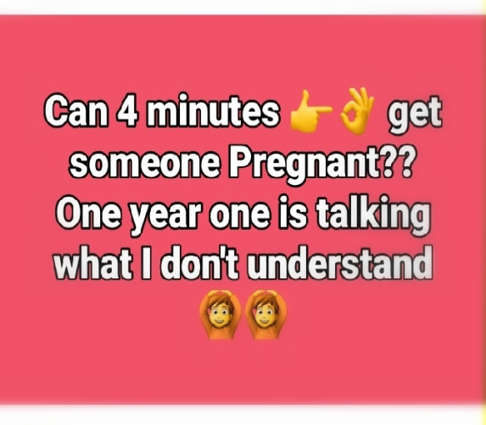

**Figure 5**

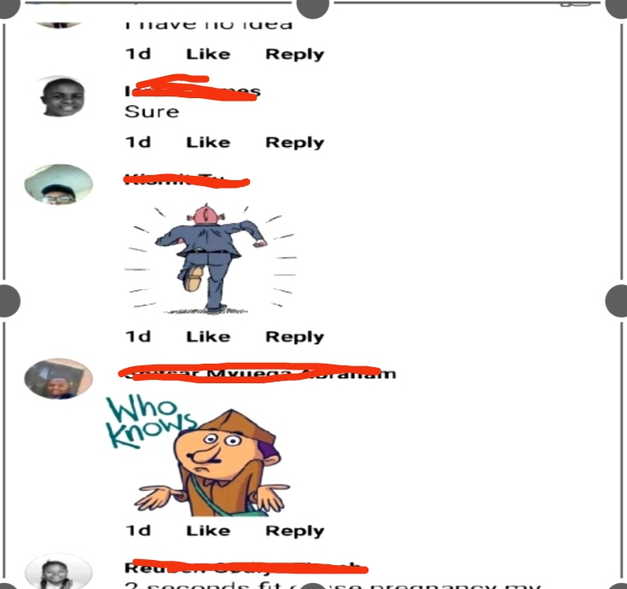

**Figure 6**

The above post consists of two utterances joined by implied discourse connectives (such as "so", "because", and "since"). The first utterance poses a question - "Can 4 minutes get someone pregnant?" A reader of this utterance who does not share similar contextual or background knowledge with the writer may lose grasp of the speaker-intended meaning, especially if the utterance is interpreted literally, as time is an abstract concept that cannot get someone pregnant. This utterance though takes minimal processing effort for students who share similar backgrounds. The emojis in the first utterance show that some part of the utterance is left out, or pending. Contextually, the writer is implicitly asking if “four (4) minutes of sex can get a girl pregnant.” The hidden meaning of this utterance can be deduced from the shared cultural knowledge that time does not get someone pregnant, but sexual intercourse can make a girl pregnant. The emojis (pointing fingers and rounded fingers) are used to depict male and female genitals as well as intercourse. Hence, only a male student can get a female student pregnant. This utterance can imply that the speaker implicitly seeks to convey meaning not expressed in the text.

Similarly, it can be creatively inferred that the addresser has experienced pre-marital sexual intercourse, possibly without the use of a condom, which produces unwanted pregnancies. The speaker is sexually unenlightened and unaware that fewer minutes of sexual intercourse can get a girl pregnant. Thus, such utterances on a social media page point to the fact that the writer requires sexual orientation.

The next utterance, “One year one is talking what I don't understand", would have been ambiguous, if not for the first utterance in the post. Through the provision of linguistic context in the first utterance, it can be deduced that the writer is saying that a year-one student is alleging to be pregnant for him. Thus, he downplays the fact that he had illicit sex over its outcome.

Moreover, it can be implied that the writer, perhaps, boasts about his sex life in his choice of words used in the utterance. This creative interpretation is deduced from his use of "talking" instead of "saying". Hence, the audience understands that the writer is saying that the girl is uttering meaningless things. This reflects the new idea the addresser intends to communicate to his addressees.

Similarly, the writer uses the emoji (hands placed on the head) to signal that he is in trouble. Its use reveals the writer's mood (a core aspect of living in a digital world that is visually driven and emotionally expressive) of despair over an unwanted pregnancy. The writer’s use of graphic representation on a public Facebook platform highlights the fact that he seeks solidarity and comfort from fellow students, though not denying his sexual experience.

The first response, “I have no idea”, suggests an attitude of indifference. It creatively means that the commentator tries to shy away from discussing sex-related issues. Thus, based on the shared African cultural context, with lots of taboo words, the commentator implies that it is not morally right to discuss such an issue on a social media platform. This, therefore, performs the cognitive function of expanding the mental representation of the world.

The next utterance, “sure”, would have made no sense without any contextual assumption. Here, the writer implicitly states that four minutes can get a girl pregnant. It can be deduced that the writer interpreted the post as a question, and therefore, provided an answer. This can be seen as the most relevant conclusion drawn from many inferred assumptions in the utterance.

The third commentator employed the use of an emoticon to reflect his/her state of mind as well as for brevity while communicating on Facebook. Here, the commentator turns to flight because of the interpretation he/she makes from the utterances in the post. It can be inferred that the commenter has concluded that the post updater has made a girl pregnant. Thus, the commenter implies through graphics that he or she is completely detached from the issue of pregnancy.

The penultimate utterance, “Who knows?" accompanied by an image is a good example of GIFs for communicative purposes on Facebook. The utterance implies that the addressee defers the answer to the question posed in the post by suggesting. Hence, nobody has a sufficient answer to the question. This respondent uses speech context to minimize the effort needed to process the utterance.

The last utterance, “2 seconds fit cause pregnancy my brother”, exemplifies the use of Nigerian pidgin in Facebook communication. Here, the writer is expressing his or her opinion regarding the question raised on the platform. It can be creatively interpreted that the commentator implies that four minutes of sex can lead to pregnancy and infers that the post-updater (who is contextually called “brother”) is responsible for the alleged pregnancy. This shows the cognitive effect of affirmation.



**Figure 7**

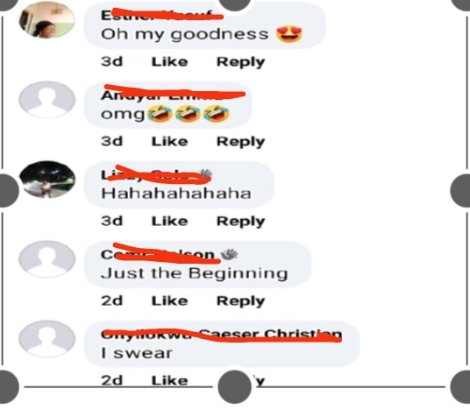

**Figure 8**

This post exemplifies students' perceptions regarding academic pursuit and experience on campus. The speaker posts - "First year in Fuwukari ya already growing white hair's because of stress". Here, the utterance transfers some information and describes the stress associated with the academic activities of students on campus in a manner that is relevant to members of this group.

Although this utterance is rendered in the nonstandard form of the English language, the speaker expresses that undergraduate students of Federal University Wukari go through strenuous academic processes capable of draining time, health, and physical and mental energy. The addresser implicitly asserts that the stress students at Federal University Wukari face on campus can induce premature aging.

The speaker’s expression implies his/her surprise that first-year students who are yet to face stressful academic activities are already showing signs of stress. This can be interpreted as the fact that the speaker only sees the negative side of an educational experience, which portrays how some students view their academic experiences as plundering mental and physical comfort. It can be creatively said that the post reflects the psychological state of the sharer.

The speaker uses two emojis - a crying face and a bewildered face with a tear - to enact the massive amount of energy he/she exerts in academic activities on campus. Contextually, the emojis are used to depict the miserable state of an undergraduate student. The emojis are used for contextual clues to elicit the communicative effect of pity.

Perhaps, the sharer implicitly recounts the limitless mental expansion and unprecedented academic maturation that students of Federal University Wukari experience as early as their first year on campus. Thus, the speaker is implying that every student is stretched, especially mentally through lengthy lectures and brain-tasking lectures as well as tough academic projects to the point that academic wisdom becomes a natural outcome for an average student of the university, regardless of the student’s year on campus.

The first comment, "Oh my goodness", portrays either shock or a sigh of dissatisfaction over the overwhelming mental, physical, or emotional stress that the communicator depicts in the post. It shows that the commentator identifies with the experience captured in the post and supports the proposition made in the utterance.

In the same vein, the emoji (eyes covered with a heart) reinforces the state of the speaker's emotion that accompanies the utterance. It creatively depicts that academic stress has weakened the eyesight of the commentator, yet his/her resolve is not hampered. Consequently, the writer, despite physical and mental exhaustion, expresses the ability to carry on with academic activities by sheer willpower. This is the optimal relevance and cognitive effect of the utterance.

The second comment, “omg”, is a shortened version of the expression, “Oh my God.” This utterance creatively means that the commentator interprets the post as extremely hilarious, and shocking. He/she laughs over the rapid transformation that students experience on campus because of academic stress. This performs the cognitive function of amusement.

Contextually, this utterance and an accompanying emoji, “rolling on the floor laughing”, reflect the effect of the excessive humor that the post creates on the commentator. Thus, the emoji aids the interpretation of the utterance and implies that the commentator is overwhelmed with a strong sense of humor from this post. This emotional outburst of laughter can also be viewed as the addressee's most optimally relevant interpretation.

The next comment, “hahahahahaha”, is an expression of laughter, an indication that the commentator interprets the post as obviously exaggerated for comical effects. Perhaps, it can be contextually inferred through the utterance that the commentator identifies with the stress associated with studying at Federal University Wukari but considers the picture of the youth growing grey hair an exaggeration. The expression of laughter could be employed to downplay the seriousness of the subject matter or elicit humor. Consequently, it is through shared contextual background knowledge that the commentator can interpret this post as an exaggeration, yet a near reflection of the stress students experience on campus.

The penultimate comment, "just the beginning", creatively implies, "This is just the beginning of your many hard years at Federal University Wukari". The note of finality in this utterance infers that the commentator has experienced intensifying academic stress every new session and is certain that more stressful years await the addresser. This utterance shows that the addressee has come to the logical conclusion that the speaker will experience more hardship.

The last comment, "I swear", is an act of agreement. The utterance implies that once one becomes a student of Federal University Wukari one is not exempted from academic stress. Thus, this utterance performs the cognitive function of affirmation. Hence, the commentator implicitly says that every student of Federal University Wukari must unavoidably go through academic stress.

**Discussion**

On Facebook, people use utterances that need supplementary contextual information to imply meaning. In other words, most of the time what is meant is not only the words that are used but the meaning that is implied. People resort to this conversational strategy, namely, indirectness. Consequently, implicatures (implied meaning) are conveyed without stating them. The posts' genuine objectives are to get people to do something not explicitly stated.

In addition, findings from the study show that it is possible to "communicate with graphics" just as with words. Information from the study reveals that different interpretations are inferred from the emoticons (icons that show emotions) and utterances posted by students on Facebook. Most of the graphics and utterances are subject to many implied meanings. It takes shared background knowledge of the interlocutors to deduce the speaker's intended meaning. It also highlights that students' utterances on Facebook can be ambiguous and that pragmatic tools (such as the context of utterance or shared background knowledge) aid in creating different interpretations. Similarly, digital communicative tools aid in interpreting the speaker's meaning or intention elicited from Facebook posts and comments.

The study shows that students often present serious subjects trivially, watering down serious concerns to induce comic effect or many interpretations.

**Conclusion**

Facebook communication provides a unique form of language used by students on campus. Students use social media to communicate varied information in different forms of the English language and on various subject matters even though some of the utterances present ambiguity in interpreting the meaning. The challenge is often understanding the speakers' intended meaning of the ambiguous utterances on the Facebook platform. This research shows that using emojis, GIFs, and Likes are some of the communicative strategies employed in Facebook communication to create a mutual cognitive context. The study also observes that students sometimes are unaware of the site's affordances and therefore, misuse social media handles created to post information on academic activities on campus to engage in disseminating information on subject matters outside the affordances of speech context and situation.

**References**

Agustin, R. W., &Ayu, M. (2021). The Impact of Using Instagram for Increasing Vocabulary and Listening Skills. *Journal of English Language Teaching and Learning,* 2(1), 1-7.

Barton, D., & Potts, D. (2013). Language learning online as a social practice. *TESOL Quarterly,* 47(4), 815-820. Retrievedfromhttps://doi.org/10.1002/tesq.130

Colston, H.L. (2018). Irony as indirectness Cross- Linguistically: on the scope of generic mechanisms. *Perspectives in pragmatics, psychology & philosophy* (pp. 109-131). Retrieved from https://doi.org/10.1007/978-3-319-78771-8_6

Cummings, L. (2015). *Pragmatics: A Multidisciplinary Perspective.* United Kingdom: Edinburgh, Edinburgh University Press.

Eger, L. (2015). Is Facebook a similar learning tool for university students as LMS? *Procedia- Social and Behavioral Sciences,* 203, 233-238. Retrieved from https://doi.org/10.1016/j.sbspro.2015.08.287

Facebook Data Team. (2012). *Making your Settings Easier to Find: Dig into the Details*. Retrieved October 14, 2020, from <https://www.facebook.com/about/details/>.

Federal University Wukari Students Forum “[Facebook page]”. Facebook. Retrieved October 14, 2020, from <https://www.facebook.com/groups/322728641436950/>

Leech, G. N. (1983). *Principles of Pragmatics*. London: Longman.

Sperber, D. (2005). Modularity and Relevance: How can a Massively Modular Mind be Flexible and Context-Sensitive? In P. Carruthers, S Laurence, & S. Stich (Eds.), *The Innate Mind: Structure and Contents.* (pp. 53-68). Jericho: Oxford University Press.

Sperber, D., & D. Wilson. (2002). Pragmatics, Modularity and Mind-Reading. Mind and Language, 17(1-2), 3-23.

We Are Social & Meltwater (2023), “Digital 2023 Global Overview Report, “retrieved from https//datareportal.com/reports/digital-2023-global-overview-report on 01 June 2023.

Wilson, D., & D. Sperber. (2002). Truthfulness and Relevance. *Mind*, 111(443), 583-632.

Wilson, D. (2009). Relevance Theory. In L. Cummings (Ed.), *The Pragmatics Encyclopedia*. (pp. 393-399). London: Routledge.

**Authors’ profiles**:

**Victor Elendu Frederick** holds a Bachelor of Arts in English and Literary Studies from Federal University Wukari, Nigeria. His research interests are cyber pragmatics, neurostylistics, creative writing, and Literary theory. **Email**: <victorfedrick03@gmail.com>.

**Vivian Ogbazi Ijeoma** was one of the best graduating students of the Class 2020 English and Literary Studies at Federal University Wukari, Nigeria. She is currently an MA student at the University of Abuja. her research interests are Children's Literature, African Literature, and Literary theory.

**Email**: <cyprainvivian6@gmail.com>.

.